Copyright ©2021-2099 FengJiaHe. All rights reserved

**例题：**

#include<iostream>

using namespace std;

class MyArray

{

public:

MyArray(int length);

~MyArray();

void Input();

void Display(string);

protected:

int *alist;

int length;

};

MyArray::MyArray(int leng)

{

if (leng <= 0)

{

cout << "error length";

exit(1);

}

length = leng;

alist = new int[length];

if (alist == NULL)

{

cout << "assign failure";

exit(1);

}

cout << "MyArray类对象已创建!" << endl;

}

MyArray::~MyArray()

{

delete[]alist;

cout << "MyArray类对象已撤销!" << endl;

}

void MyArray::Display(string str)

{

int i;

int *p = alist;

cout << length << "个整数:";

for (i = 0;i < length;i++, p++)

cout << *p << "";

cout << endl;

}

void MyArray::Input()

{

cout << "请从键盘输入" << length << "个整数:";

int i;

int *p = alist;

for (i = 0;i < length;i++, p++)

cin >> *p;

}

int main()

{

MyArray a(5);

a.Input();

a.Display("显示已经输入的");

return 0;

}

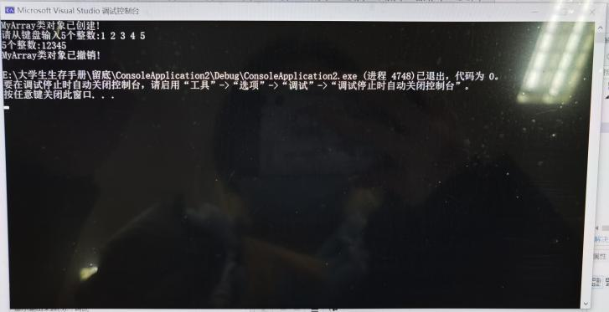

**练习：**

#include<iostream>

#include<string>

using namespace std;

class MyArray

{

public:

MyArray(int length);

~MyArray();

void Input();

void Display(string);

protected:

int* alist;

int length;

};

MyArray::MyArray(int leng)

{

if (leng <= 0)

{

cout << "error length";

exit(1);

}

length = leng;

alist = new int[length];

if (alist == NULL)

{

cout << "assign failure";

exit(1);

}

cout << "MyArray类对象已创建!" << endl;

}

MyArray::~MyArray()

{

delete[]alist;

cout << "MyArray类对象已撤销!" << endl;

}

void MyArray::Display(string str)

{

int i;

int* p = alist;

cout << str << length << "个整数:";

for (i = 0;i < length;i++, p++)

cout << *p << " ";

cout << endl;

}

void MyArray::Input()

{

cout << "请从键盘输入" << length << "个整数:";

int i;

int* p = alist;

for (i = 0;i < length;i++, p++)

cin >> *p;

}

class SortArray :public MyArray {

public:

void Sort();

SortArray(int leng) :MyArray(leng)

{

cout << "SortArray类对象已创建!" << endl;

}

~SortArray();

};

SortArray::~SortArray()

{

cout << "SortArray类对象已撤销!" << endl;

}

void SortArray::Sort()

{

int i, j, temp;

for (i = 0;i < length - 1;i++)

for (j = 0;j < length - i - 1;j++)

if (alist[j] > alist[j + 1])

{

temp = alist[j];

alist[j] = alist[j + 1];

alist[j + 1] = temp;

}

}

int main()

{

SortArray s(5);

s.Input();

s.Display("显示排序以前的");

s.Sort();

s.Display("显示排序以后的");

return 0;

}

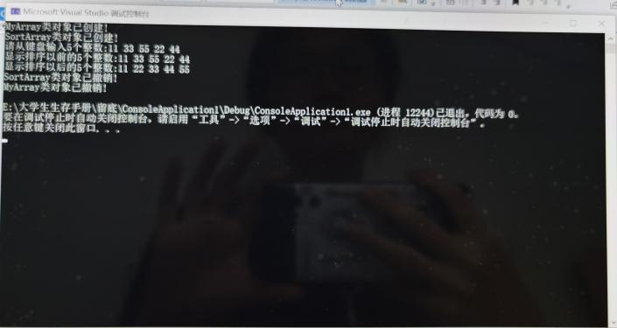

**感想心得：**

通过本次实验，我掌握了派生类的声明方法和派生类构造函数的定义方法，构造函数与析构函数的执行顺序与构造规则。

练习过程中，我发现自己在部分函数中容易逻辑不清，length与leng使用混乱。通过询问老师解决了问题，今后将会加强逻辑练习。